**National University of Computer & Emerging Sciences, Karachi  
Fall -2024**

**ASSIGNMENT NO.3 (Electric Field and force)  
27th November 2024**

|  |  |  |
| --- | --- | --- |
| **Course Code: NS(1001)** | **Course Name: Applied Physics** | |
| **Instructor Name Rabia Tabassum** | | |
| **Student Roll No & Section** | | **Submission deadline 02-12-2024** |

***Instructions for Submission:***

* *Soft copy only*
* *You are required to Submit the Assignment in softcopy on Google Classroom.*
* ***Strictly follow the deadline***

1. Two point charges are located on the positive x-axis of a coordinate system. Charge q1=3.0nC is 2.0cm from the origin, and charge q2=-7.0nC is 4.0cm from the origin. What is the magnitude and direction of resultant force exerted by these two charges on third point charge q3=5.0nC located at the origin?
2. A point charge q1=2.0 uC is located on the positive y-axis at y=0.3m, and an identical charge q2 is at the origin. What is the magnitude and direction of resultant force exerted by these two charges on third point charge q3=4.0uC located at positive x-axis at x=0.40m?
3. In the figure below, a configuration of four closed surfaces and three charges of -2Q,  +Q, and -Q is shown. What is the electric flux through each surface?

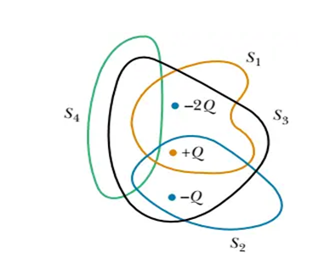

1. Two equally charged particles are held 3.2 x 10-3m apart and then released from rest. The initial acceleration of the first particle is observed to be 7.0 m/s2 and that of the second particle to be 9.0 m/s2. If the mass of the first particle is 6.3 x 10-7 Kg, what are (a) the mass of the second particle and (b) the magnitude of the charge of each particle ?
2. Two small, positively charged spheres have a combined charge of 5.0 x10^5 C. If each sphere is repelled from the other by an electrostatic force of 1.0 N when the spheres are 2.0 m apart, what is the charge on the sphere with the smaller charge?